1MAA  1 MATHEMATICS WITH ALGEBRA |  |  |  | N
In this course, you will still cover all aspects of mathematics, Number, Measurement, Geometry, Algebra, and Statistics. However, you will explore deeper into algebraic methods to generalise and represent patterns and relationships in numbers, shapes, and measurements. Learning contexts will have a broad range of practical applications in everyday life, our local environment, and in workplaces. This course will suit you if you are interested in pursuing the Algebra and Calculus pathway. This course is recommended if you intend to take 2ACA.

 |  |  |  |  | 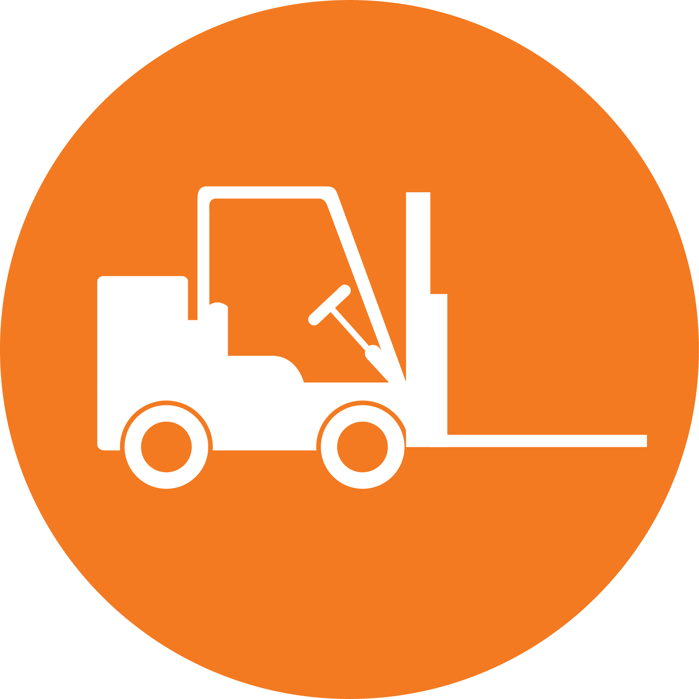
CREATIVE INDUSTRIES | SOCIAL & COMMUNITY SERVICES | MANUFACTURING & TECHNOLOGY | SERVICE INDUSTRIES | PRIMARY INDUSTRIES | CONSTRUCTION & INFRASTRUCTURE

Mathematics
LEARNING OBJECTIVES:
- You will develop skills and understanding of concepts across the mathematics curriculum
- You will learn to structure and to organise, to carry out procedures flexibly and accurately, and to process and communicate information
- You will develop models and predict outcomes, justify and verify, and seek patterns and generalisations
- You will learn to estimate with reasonableness, calculate with precision, and understand when results are precise and when they must be interpreted with uncertainty

Int/Ext | Standard | Level | Title | Assessment Mode | Credits | L1 Lit | L1 Num | UE Read | UE Write
Internal | AS91944 | Level 1 | Explore data using a statistical enquiry process | Investigation | 5
Internal | AS91945 | Level 1 | Use mathematical methods to explore problems that relate to life in Aotearoa New Zealand or the Pacific | Context Problem | 5
External | AS91947 | Level 1 | Demonstrate mathematical reasoning | Exam | 5

