1MAS  1 MATHEMATICS WITH STATISTICS |  |  |  | N
In this course, you will still cover all aspects of mathematics, Number, Measurement, Geometry, Algebra, and Statistics. However, you will explore deeper into statistical methods and the statistics enquiry cycle. You will also learn ways to critique the use of statistics in the real world. Learning contexts will have a broad range of practical applications in everyday life, our local environment, and in workplaces. This course will suit you if you are interested in pursuing the Statistics pathway. This course is recommended if you intend to take 2STA.

 |  |  |  |  | 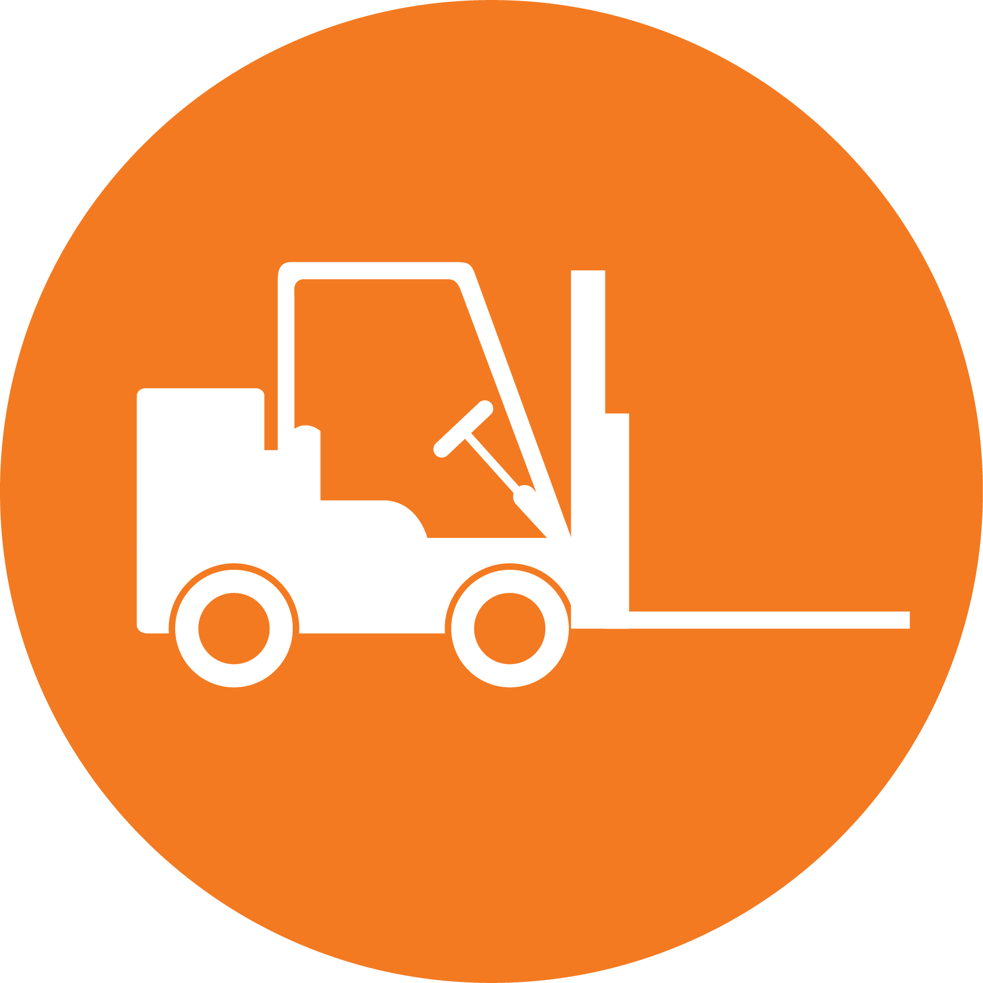
CREATIVE INDUSTRIES | SOCIAL & COMMUNITY SERVICES | MANUFACTURING & TECHNOLOGY | SERVICE INDUSTRIES | PRIMARY INDUSTRIES | CONSTRUCTION & INFRASTRUCTURE

Mathematics
LEARNING OBJECTIVES:
- You will develop skills and understanding of concepts across the mathematics curriculum
- You will learn to structure and to organise, to carry out procedures flexibly and accurately, and to process and communicate information
- You will develop models and predict outcomes, justify and verify, and seek patterns and generalisations
- You will learn to estimate with reasonableness, calculate with precision, and understand when results are precise and when they must be interpreted with uncertainty

Int/Ext | Standard | Level | Title | Assessment Mode | Credits | L1 Lit | L1 Num | UE Read | UE Write
Internal | AS91944 | Level 1 | Explore data using a statistical enquiry process | Investigation | 5
Internal | AS91945 | Level 1 | Use mathematical methods to explore problems that relate to life in Aotearoa New Zealand or the Pacific | Context Problem | 5
External | AS91946 | Level 1 | Interpret and apply mathematical and statistical information in context | External Portfolio | 5

