2ACA  2 ALGEBRA & CALCULUS |  |  |  | N
In this course, you will explore a range of algebraic methods and calculus. You will explore algebraic methods to generalise and represent patterns and relationships in numbers, shapes, and measurements. You will be introduced to the fundamentals of differentiation and antidifferentiation, commonly known as calculus. This course will suit you if you are interested in pursuing pure mathematics, engineering, and architecture fields in the future. It will also be beneficial if you are looking to take Physics and/or Chemistry and intend to take 3ACA.

 |  |  |  |  | 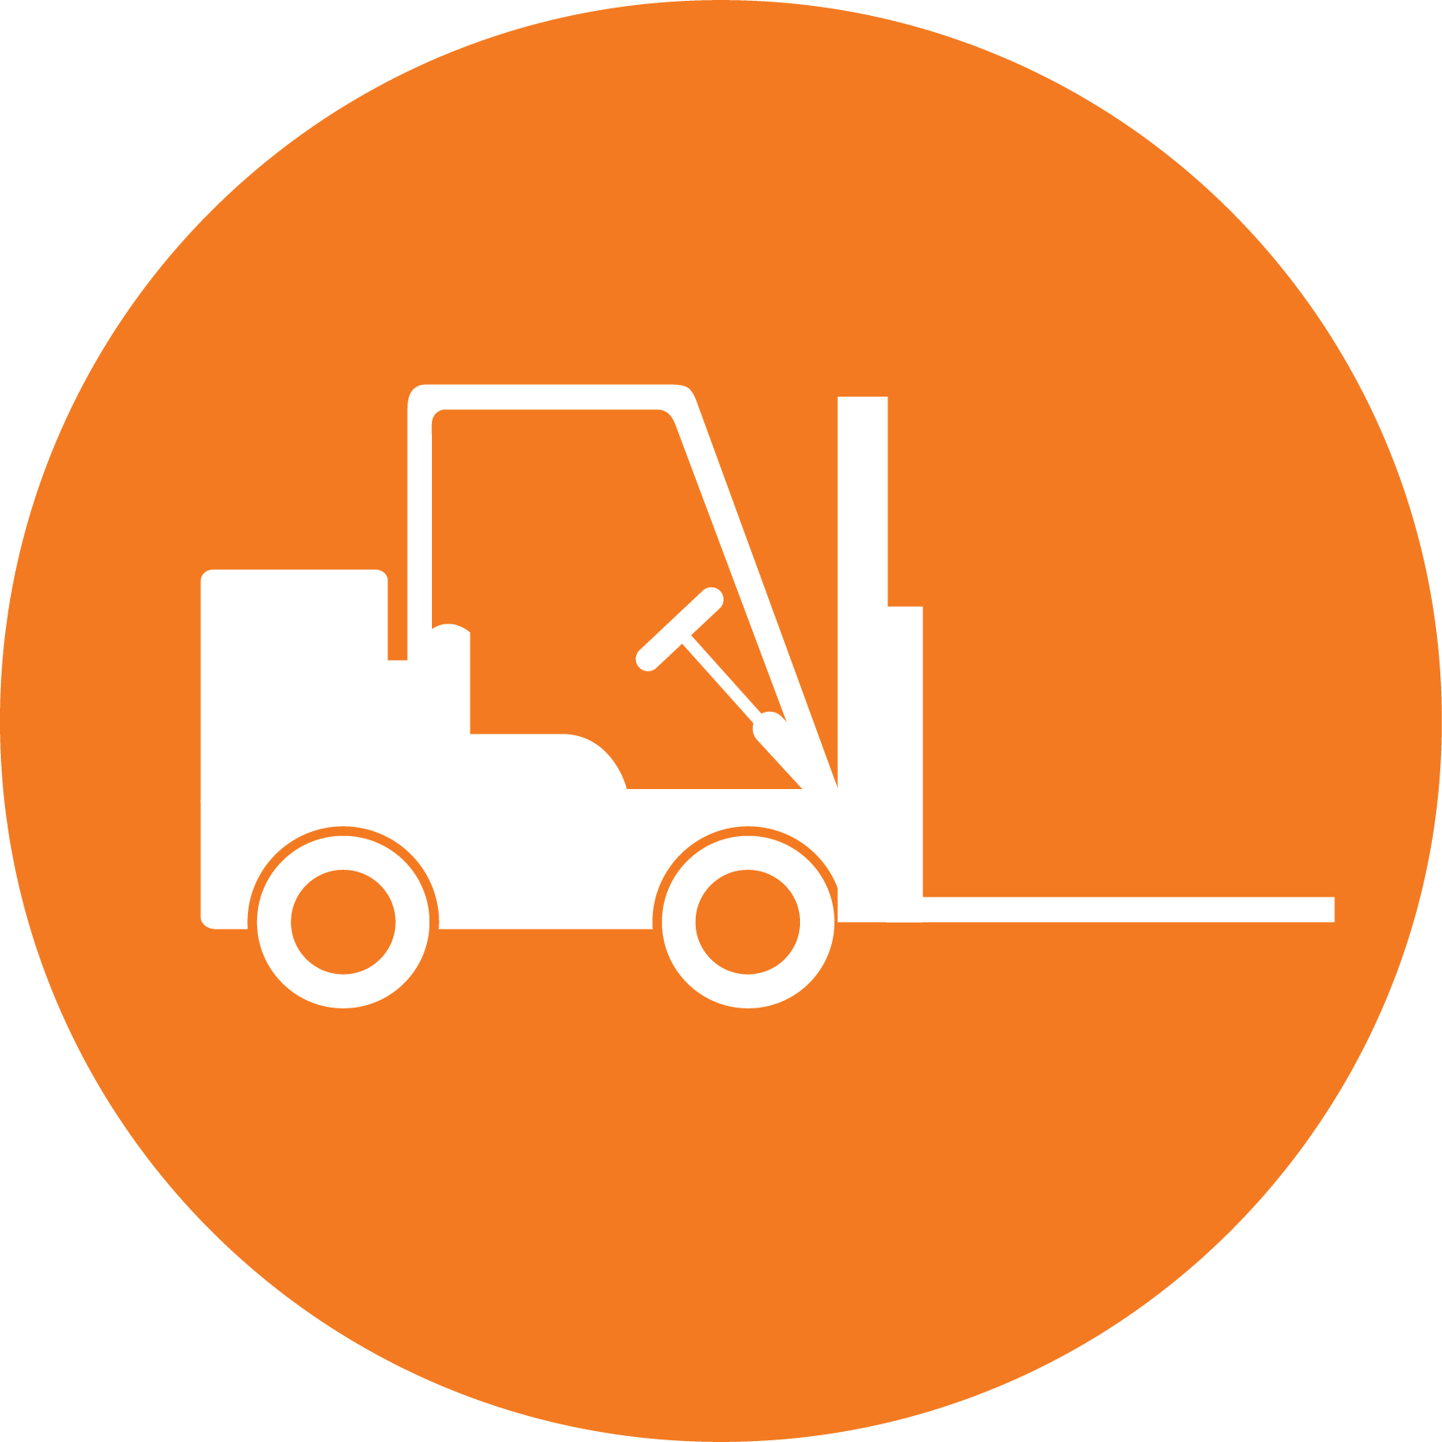
CREATIVE INDUSTRIES | SOCIAL & COMMUNITY SERVICES | MANUFACTURING & TECHNOLOGY | SERVICE INDUSTRIES | PRIMARY INDUSTRIES | CONSTRUCTION & INFRASTRUCTURE

Mathematics
LEARNING OBJECTIVES:
- You will explore algebraic methods to generalise and represent patterns and relationships found in numbers, shapes and measures
- You will use arithmetic and geometric sequences and series to solve real-life problems
- You will manipulate rational, exponential, and logarithmic algebraic expressions, and form and use linear and quadratic equations
- You will understand the fundamentals of differentiation and antidifferentiation (a.k.a. calculus)
- You will sketch the graphs of functions and their gradient functions and describe the relationship between these graphs

Int/Ext | Standard | Level | Title | Assessment Mode | Credits | L1 Lit | L1 Num | UE Read | UE Write
Internal | AS91256 | Level 2 | Apply coordinate geometry methods in solving problems | Context Problem | 2
Internal | AS91269 | Level 2 | Apply systems of equations in solving problems | Context Problem | 2
Internal | AS91257 | Level 2 | Apply graphical methods in solving problems | Context Problem | 4
External | AS91261 | Level 2 | Apply algebraic methods in solving problems | Exam | 4
External | AS91262 | Level 2 | Apply calculus methods in solving problems | Exam | 5

