1PED
1 Physical Education:
In, through, and about movement.

In this course, you will learn about the human body, through biomechanics and anatomy of movement while also learning how to co-operate and lead others in a group environment. Physical Education is much more than being physically capable. In this course, you will learn to understand what influences us and how to enhance all aspects of movement in a variety of contexts. We will explore the deeper connection to self that makes an athlete successful, understanding how to apply ourselves in our sport, education, well-being, and lifestyle in Aotearoa, New Zealand and the Pacific.

 |  |  |  |  | 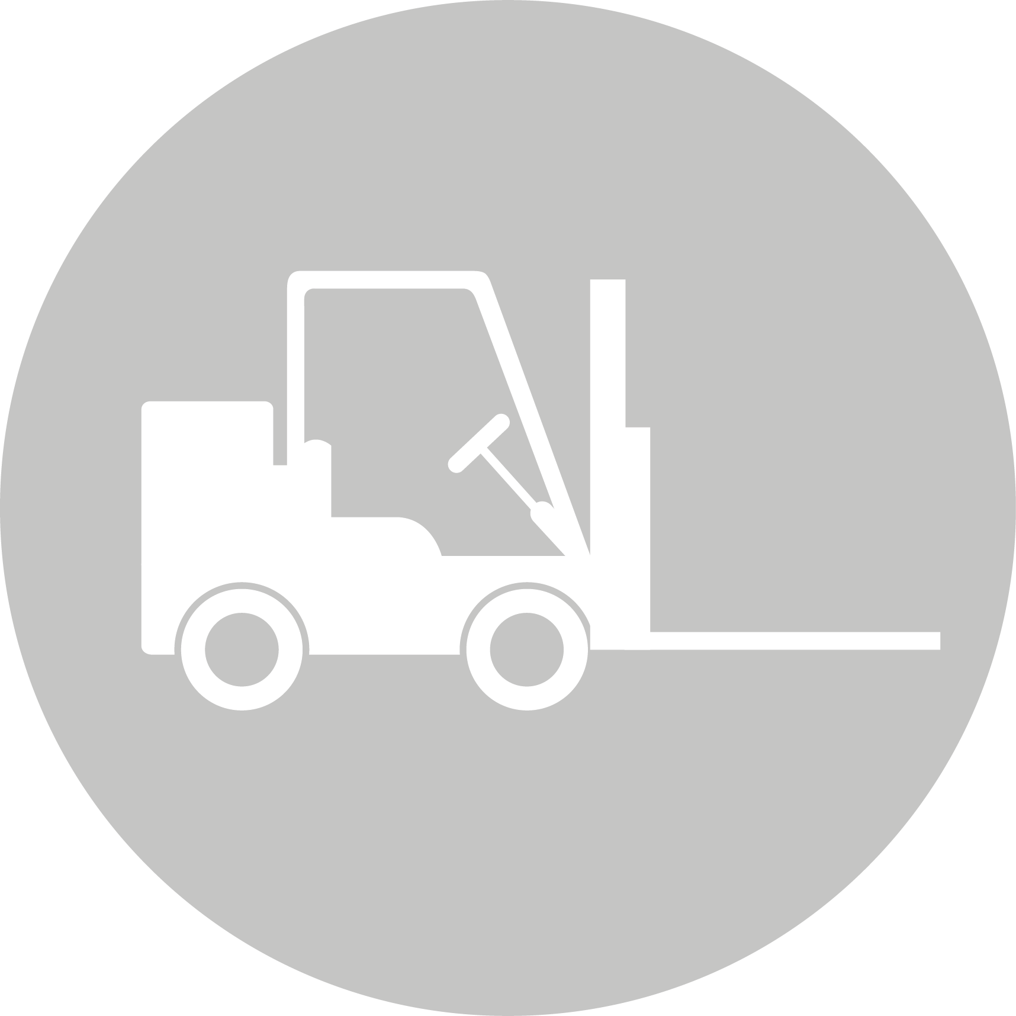
CREATIVE INDUSTRIES | SOCIAL & COMMUNITY SERVICES | MANUFACTURING & TECHNOLOGY | SERVICE INDUSTRIES | PRIMARY INDUSTRIES | CONSTRUCTION & INFRASTRUCTURE

Physical Education and Health
LEARNING OBJECTIVES:
- You will learn about how the body moves and applies biophysical principles during a variety of physical activity.
- You will perform to the best of your ability in a range of sports and activities, demonstrating a range of movement strategies.
- You will learn about the dynamics of leadership and strategies that enhance teamwork.
- You will develop an understanding of personal, interpersonal, and societal influences on movement and wellbeing.

Int/Ext | Standard | Level | Title | Assessment Mode | Credits | L1 Lit | L1 Num | UE Read | UE Write
Internal | AS92016 | Level 1 | Apply movement strategies in an applied setting | Written, Practical Visual | 5
Internal | AS92017 | Level 1 | Demonstrate understanding of the application of strategies in movement | Written, Practical | 5
External | AS92018 | Level 1 | Demonstrate understanding of the influence of personal movement experiences on Hauora | Portfolio | 5
External | AS92019 | Level 1 | Demonstrate understanding of influences on movement in Aotearoa New Zealand or the Pacific | Written, Exam | 5

