3CHE  3 Chemistry |  |  |  |  | R | W
This Level 3 Chemistry course explores thermochemistry, oxidation-reduction, and the structure/reactivity of organic compounds, including their analytical identification. You'll also examine organic chemistry's connection to global and environmental issues impacting daily life. Through local and global contexts, you'll investigate the role of material science in society. Learning experiences will include investigative, research, and examination-based tasks.

 |  |  |  |  | 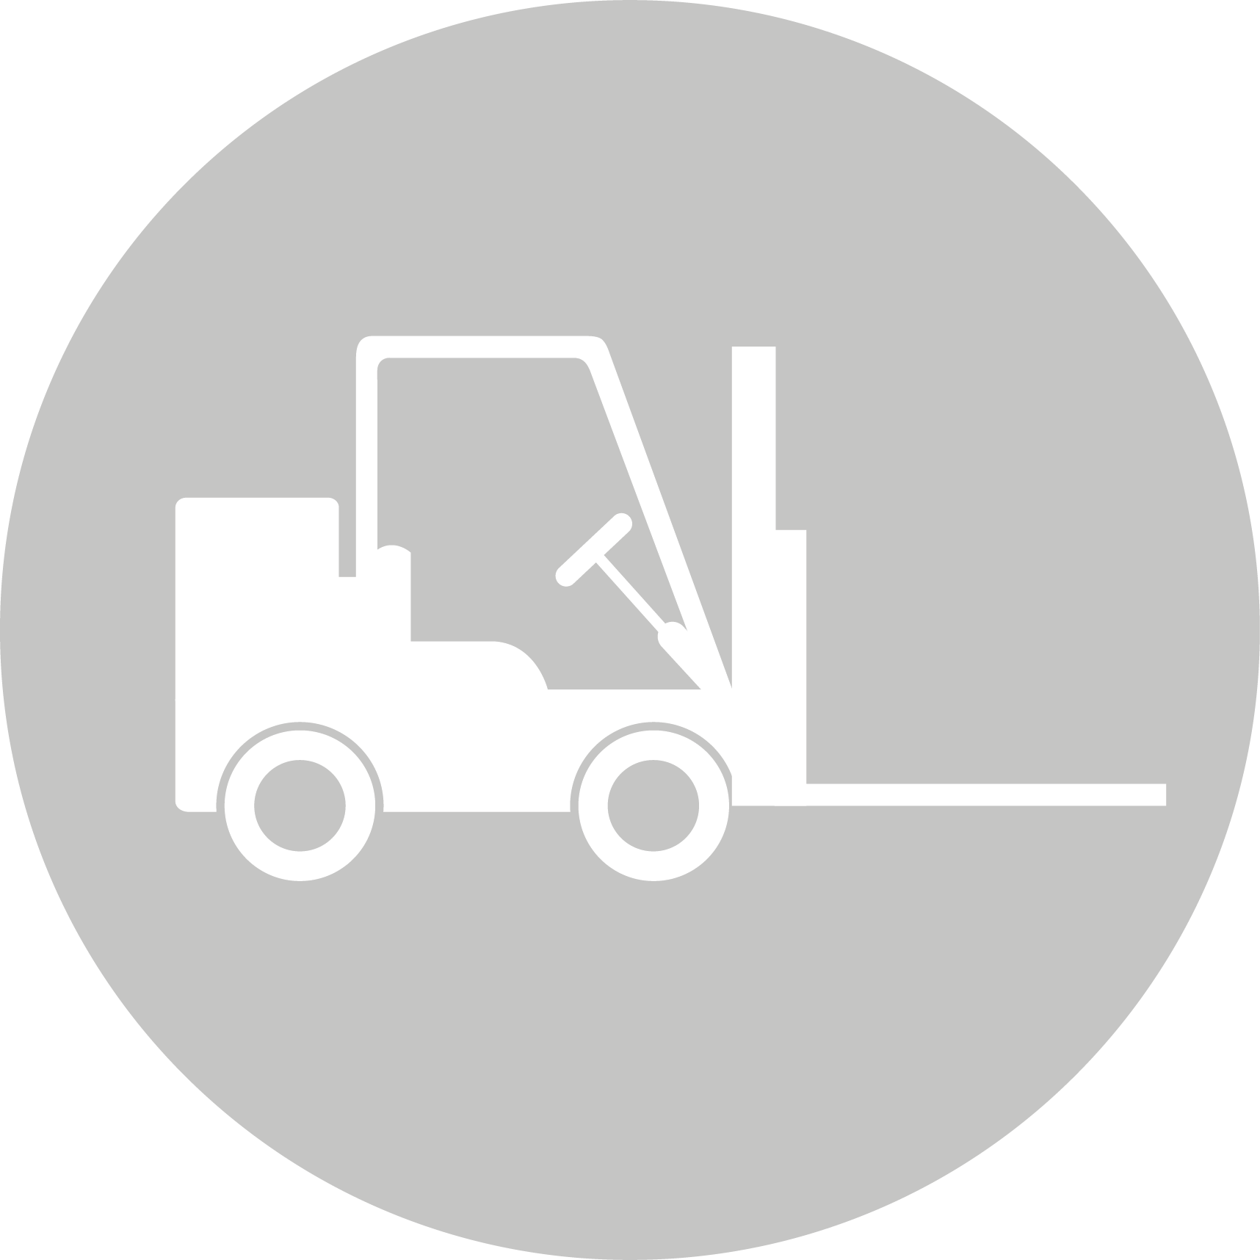
CREATIVE INDUSTRIES | SOCIAL & COMMUNITY SERVICES | MANUFACTURING & TECHNOLOGY | SERVICE INDUSTRIES | PRIMARY INDUSTRIES | CONSTRUCTION & INFRASTRUCTURE

Science
LEARNING OBJECTIVES:
- Investigate and measure the chemical and physical properties of a range of groups of substances, for example, acids and bases, oxidants and reductants, and selected organic and inorganic compounds
- Apply knowledge of chemistry to explain aspects of the natural world and how chemistry is used in society to meet needs, resolve issues, and develop new technologies
- Develop and carry out investigations that extend their science knowledge, including developing their understanding of the relationship between investigations and scientific theories and models
- Develop an understanding of and use the fundamental concepts of chemistry (for example, equilibrium and thermochemical principles) to interpret observation

Int/Ext | Standard | Level | Title | Assessment Mode | Credits | L1 Lit | L1 Num | UE Read | UE Write
Internal | AS91388 | Level 3 | Demonstrate understanding of spectroscopic data in chemistry | Written | 3
Internal | AS91389 | Level 3 | Demonstrate understanding of chemical processes in the world around us | Written | 3
External | AS91390 | Level 3 | Demonstrate understanding of thermochemical principles and the properties of particles and substances | Exam | 5
Internal | AS91393 | Level 3 | Demonstrate understanding of oxidation-reduction processes | Written | 3

