2HAK
2 Te Ao Haka
In Te Ao Haka, you’ll get to dive into cool stuff like waiata (songs), mōteatea (chants), haka (war cries), and mau rākau (Māori weapon skills). You’ll learn how to perform each one, plus pick up some important tikanga (customs) like karakia (prayers) and pūrākau (stories) along the way. It’s a great way to connect with Māori culture and have fun doing it!

 |  |  |  |  | 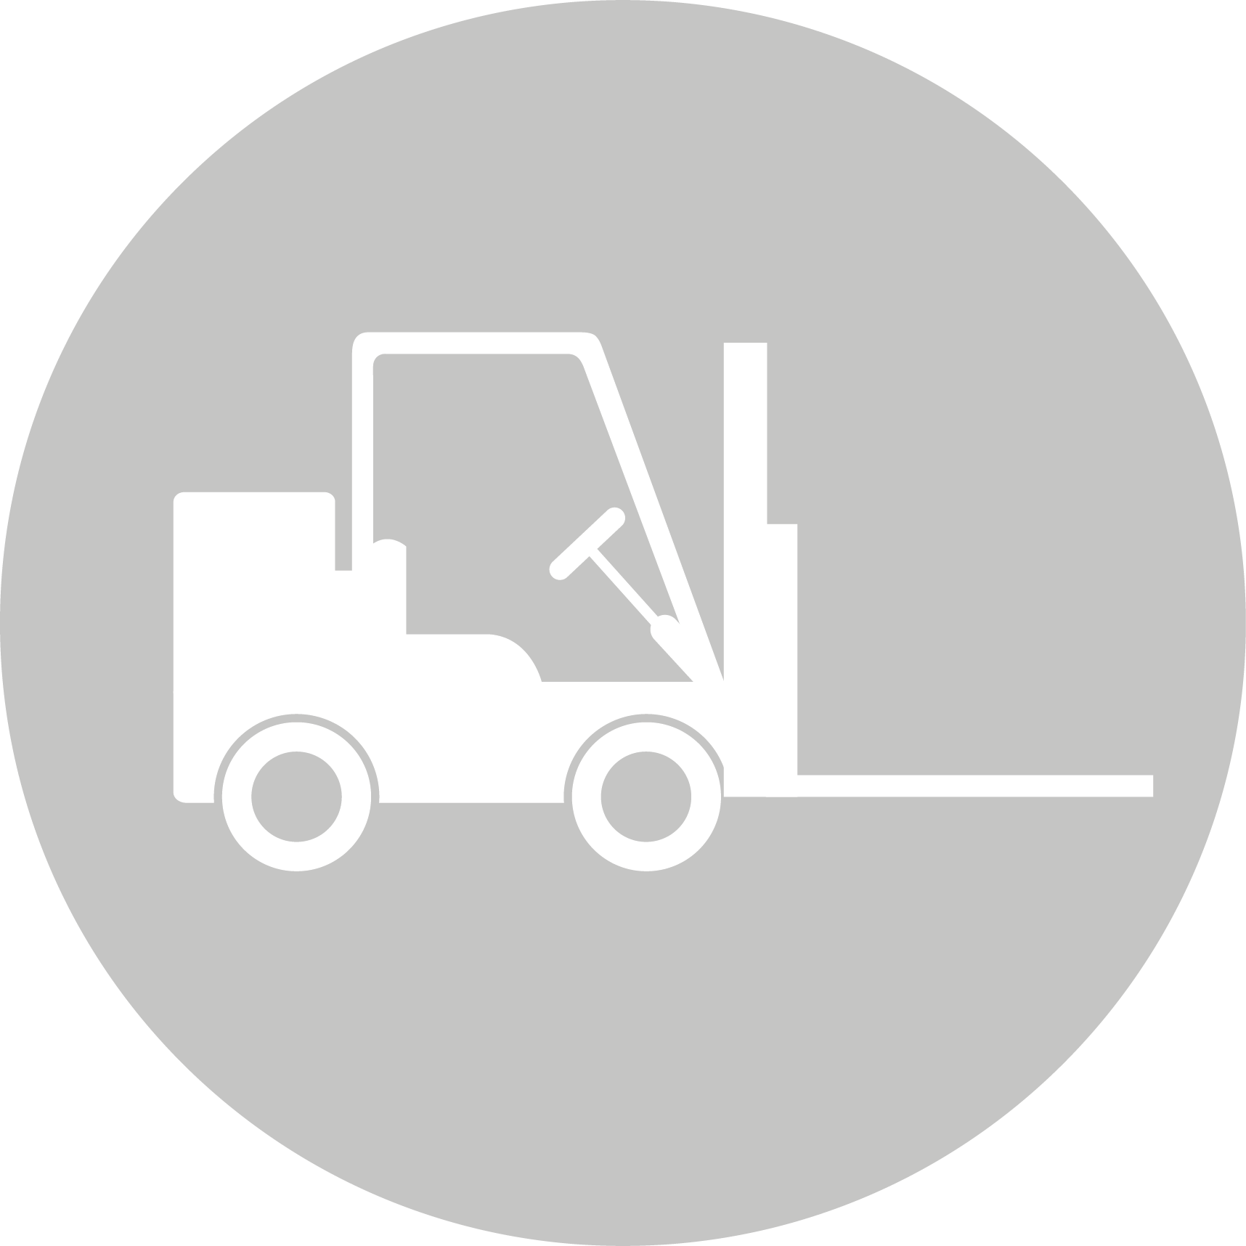
CREATIVE INDUSTRIES | SOCIAL & COMMUNITY SERVICES | MANUFACTURING & TECHNOLOGY | SERVICE INDUSTRIES | PRIMARY INDUSTRIES | CONSTRUCTION & INFRASTRUCTURE

Te Ao Māori
LEARNING OBJECTIVES:
- Gain a deep understanding of Te Ao Haka, a culturally responsive art form rooted in Māori culture, language, and tradition
- Recognise the integral role of culture, language, and identity within Te Ao Haka as vehicles for sharing and preserving Māori culture, tikanga, and knowledge systems
- Develop a strong connection to family, marae, iwi, hapū, and waka
- Embrace the performing arts as a means of empowerment and self-expression

Int/Ext | Standard | Level | Title | Assessment Mode | Credits | L1 Lit | L1 Num | UE Read | UE Write
Internal | US22756 | Level 2 | Perform a Māori performing arts bracket | Performance | 10
Internal | US27548 | Level 2 | Perform tētahi momo rākau whawhai | Performance | 10

