2PAI
2 Visual Art Painting
‘Finding Your Form – Crafting Visual Narratives’ is for students wanting to deepen their understanding of painting and mixed media through a thematic inquiry of personal interest. You’ll explore diverse techniques such as collage, digital painting, and 2D relief sculpture, while developing ideas through visual and written investigations. Customary and contemporary artist models, both local and international, will inform your practice. Internal assessments build toward a resolved body of work for your external folio. Expect to refine ideas, think critically, and explore genres like abstraction, realism, and surrealism. Level 1 Art or Photo Design is recommended. 20–24 credits are available.

 |  |  |  |  | 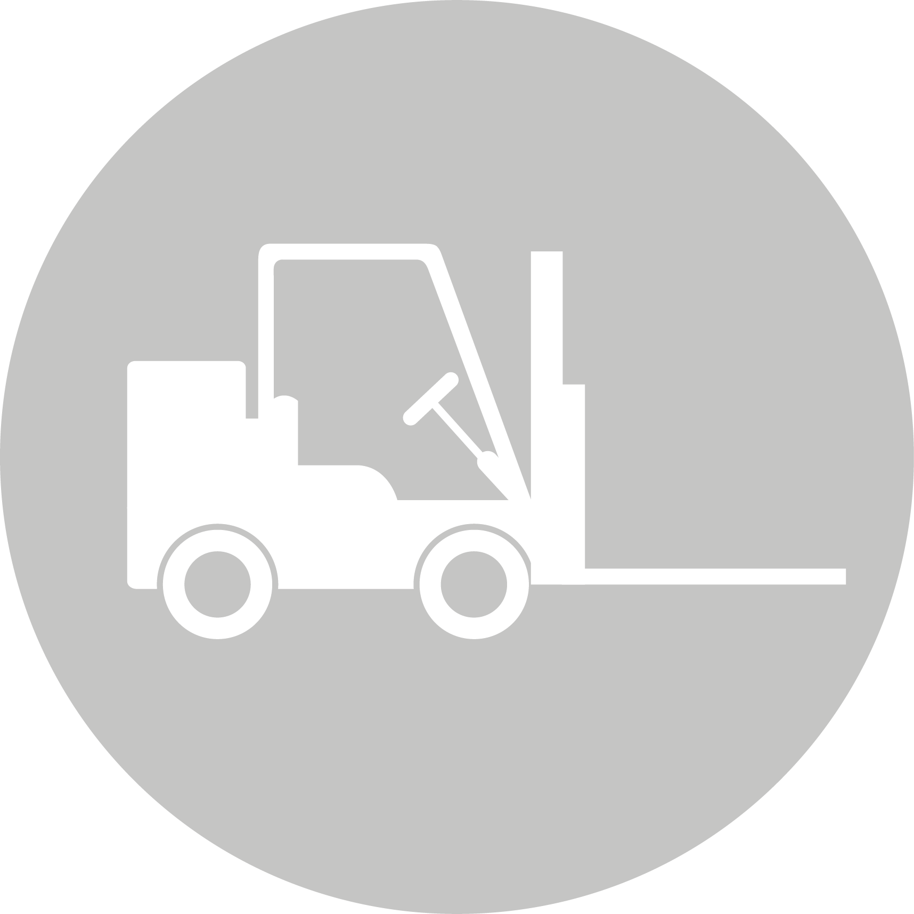
CREATIVE INDUSTRIES | SOCIAL & COMMUNITY SERVICES | MANUFACTURING & TECHNOLOGY | SERVICE INDUSTRIES | PRIMARY INDUSTRIES | CONSTRUCTION & INFRASTRUCTURE

Visual Arts
LEARNING OBJECTIVES:
- Students will understand the visual arts in context Investigate and analyse the relationship between the production of artworks and the contexts in which they are made, viewed, and valued
- Consider and reflect on the contexts underlying their own and others’ work
- Develop practical knowledge
- Apply knowledge of a range of conventions from established practice, using appropriate processes and procedures
- Generate, develop, and clarify ideas, showing some understanding of established practice
- Sequence and link ideas systematically as they solve problems in a body of work, using observation and invention with an appropriate selection of materials
- Identify and analyse processes and procedures from established practice that influence ways of communicating meaning
- Investigate, analyse, and evaluate ideas and interpret artists’ intentions in artworks

Int/Ext | Standard | Level | Title | Assessment Mode | Credits | L1 Lit | L1 Num | UE Read | UE Write
Internal | 91311 | Level 2 | 2.2 Use drawing methods to apply knowledge of conventions appropriate to painting | Visual, | 4
Internal | 91316 | Level 2 | Develop ideas in a related series of drawings appropriate to established painting practice | Visual | 4
External | 91101 | Level 2 | Produce a systematic body of work that shows understanding of art making conventions and ideas within painting | Portfolio | 12
Internal | 91325 | Level 2 | *Produce a resolved work that demonstrates control of skills appropriate to cultural conventions | Visual | 4
Internal | 91306 | Level 2 | Demonstrate an understanding of methods and ideas from established practice appropriate to painting | Written | 4

